The e-car: Electronics technology applied to sustainable mobility, Part 3

该电动汽车：电子技术可持续移动应用，3

Electronics technology is contributing heavily to the automotive industry with ICs for the DC-DC conversion utilized in the creation of voltages suitable for the central processor to enable actuators and to process the signals coming from the electronic sensors. This implies that ICs can be integrated on a large scale into modern cars and this process has a continuously growing trend:

电子技术对汽车工业产生了巨大的影响，用于制造用于中央处理器的电压的DC-DC转换芯片，使执行器能够处理来自电子传感器的信号。这意味着集成电路可以大规模地集成到现代汽车中，这个过程有不断增长的趋势：

Whats interesting is the way technology and automotive are starting to look like a single sector. Nvidia are cheek by jowl with Toyota, Kia, Continental, ZF and Valeo in the automotive sector. The Ford booth was all about the living street, with two autonomous vehicles, positioning them as a mobility and smart city pioneer. Were seeing an evolution of our industry with automakers looking well beyond the vehicle itself to the full ecosystem.

什么有趣的是技术和汽车开始看起来像是一个部门的方式。NVIDIA公司通过与丰田、起亚、大陆紧密，在汽车领域的ZF和法雷奥。福特的展台周围都是街道，有两辆自行车道，把他们定位为一个机动性和智能城市先锋。我们重新看到汽车制造商期待远远超出车辆本身的完整的生态系统对我们行业的变革。

Everything is Connected

一切都是相连的

Abundant Artificial Intelligence (AI)

丰富的人工智能（AI）

The Augmented Driving Experience

增强驾驶经验

Electrification

电气化

Fully Autonomous Mobility

充分的自主性和移动性

(Source: Five CES 2018 Takeaways Driving Automotive Electronics)

（来源：五CES 2018外卖驱动汽车电子）

In particular, the fourth point of this interesting blog by Dr. Rainer Constapel reports:

特别是，由Rainer Constapel博士报告了这个有趣的博客第四点：

 The number of electric and hybrid cars on the roads is growing at a rapid rate. At CES, that trend is even faster. The industry is gradually overcoming range-anxiety issues that have slowed adoption, and now just about every car maker has a solid electric offering. Whats more, they dont look like geek-mobiles anymore, they have the style, panache and the performance that has the potential to bring the most ardent petrol head into the eco-fold. (Source: jabil.com)

电动和混合动力汽车在道路上的数量在快速增长。在CES上，这一趋势更快。该行业正在逐步克服那些让汽车的使用放缓的范围焦虑问题，而现在几乎每个汽车制造商都有可靠的电动产品。什么的更多，他们也不像极客手机了，他们的风格，华丽的表演，带来最热情的汽油进入生态倍的潜力。（来源：公司网站）

Electronics technologys contribution has recently become even more important with the introduction of the electric car that utilizes electric energy to power the motor and the control circuitry including sensors, actuators, air conditioning, wireless charging, connectivity. (see Figure 1)

电子科技的贡献已成为近年来随着电动汽车利用电能功率的电机和控制电路包括传感器、执行器、空调、无线充电技术的引入更为重要的是，连接。（参见图1）

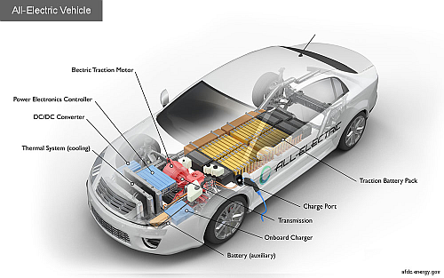

图1: The electronics technology contribution to the electric car is very valuable.

图1: 电子技术对电动汽车的贡献是非常宝贵的。

Source: U.S. Department of Energy

资料来源：美国能源部

The electric car is becoming a widely adopted solution for the automotive market because it guarantees zero-emission mobility that reduces air pollution and makes the urban environment healthier and more comfortable:

电动汽车正成为汽车市场广泛采用的解决方案，因为它保证了零排放的机动性，减少了空气污染，使城市环境更健康、更舒适：

Royal Mail, an important postal service and courier company in the UK, unveiled a new electric truck made by Arrival. The company is starting a trial today with 3 versions of the vehicle to transport packages between its mail and distribution centers around London. Paul Gatti, Royal Mail Fleets Managing Director, said that a successful trial could lead to a broader adoption of the technology in the companys fleet of almost 50,000 vehicles (Source: electreck. See Figure 2)

皇家邮政在英国的一个重要的邮政和快递公司，推出了一个新的电动汽车的到来。该公司今天开始试验，有3种版本的车辆在伦敦的邮件和配送中心之间运输包裹。Paul Gatti，英国皇家邮政车队的常务董事说，试制成功可能会导致更广泛的采用的技术在公司的近50000辆汽车的车队（来源：electreck。参见图2）

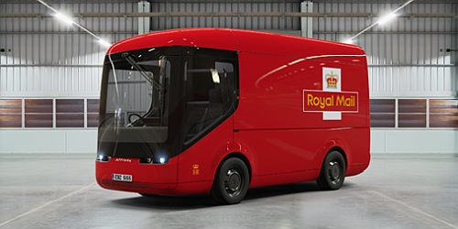

图2: The electric bus made by Arrival Company for zero emission postal transportation, holds promises to become widely adopted in all big urban areas to reduce air pollution. > (Source: <a href="https://electrek.co/2017/08/23/royal-mail-new-electric-autonomous-truck-arrival/"target="new">electreck</a>.)

图2: 为零排放的邮政运输公司所做的电动公共汽车，有望在所有大城市地区被广泛采用，以减少空气污染。>（来源：< a href =“http：/ / electrek公司/ 2017 / 08 / 23 /皇家邮政新电自治卡车到达“目标=“新”> electreck </a>。）

The electric bus requires electronic circuitry that can operate in an automotive environment with good efficiency; SiC is a perfect substrate for this task:

电动汽车需要电子线路，可以在汽车环境中工作，效率高；SIC是完成这项任务的理想基础：

Silicon Carbide is a material made of silicon (Si) and carbon (C) atoms organized in a lattice. It has long been known to operate in high-temperature, high-power, high-frequency, and high-radiation environments, thanks to its wide bandgap. To understand the properties of wide-bandgap materials, we must dive into solid state physics. Solids are made of atoms, which, if we take the most simplistic approach, are made of a nucleus and one or more electrons. (Source: blog.st.com)

碳化硅是用硅材料（Si）和碳（C）的组织在一个晶格原子。众所周知，它在高温、大功率、高频和高辐射环境中工作，由于它的宽带隙。为了理解宽禁带材料的特性，我们必须深入到固体物理学中去。固体，都是由原子组成的，其中，如果我们采取最简单的方法，是由一个核和一个或多个电子。（来源：博客。st.com）

The next part of this blog series contains some interesting characteristics of this new material and some possible applications of SiC-based power ICs in the electric transportation market.

这个博客系列的下一部分包含了这一新材料的一些有趣的特性，以及在电力运输市场中基于SIC的功率集成电路的一些可能的应用。